**Recommendation Systems: Unleashing Personalization**

**Abstract:**

Recommendation systems hold significant importance across diverse domains, serving as indispensable tools that assist users in their decision-making endeavors by offering suggestions of items or content tailored to their preferences and historical interactions. This paper undertakes a thorough exploration into the development and deployment of a recommendation system, employing a variety of methodologies such as correlation analysis, weighted averaging, nearest neighbor algorithms, and cosine-sine similarity calculations. Through the utilization of the IMDb dataset as a prime example, we aim to illustrate the efficacy and practicality of these techniques in crafting personalized recommendations. Our objective is to furnish readers with a comprehensive comprehension of recommendation systems, elucidating their vital role in everyday life, and furnishing detailed elucidations of each employed method, catering to both technical and non-technical audiences alike.

**Introduction:**

As the digital landscape continues to expand exponentially, users are frequently confronted with the daunting task of navigating through a vast array of content and products, seeking those that resonate with their individual interests and preferences. In response to this burgeoning challenge, recommendation systems emerge as indispensable tools, employing sophisticated algorithms to scrutinize user behavior and proffer tailored suggestions. Whether it's e-commerce platforms steering shoppers towards relevant products or streaming services guiding viewers to captivating movies or shows, recommendation systems have seamlessly woven themselves into the fabric of our everyday experiences. Against this backdrop, our paper embarks on a comprehensive journey delving into the intricacies of recommendation systems, examining their implementation through diverse methodologies and meticulously evaluating their effectiveness with the aid of the IMDb dataset as a quintessential case study.

**Methodology:**

**Content-based recommendation systems** analyze the intrinsic characteristics of items and user preferences to generate personalized recommendations. These systems rely on the features or attributes of items, such as text descriptions, genres, or metadata, to build user profiles and recommend items that match the user's preferences. By comparing the features of items to the user's profile, content-based systems can recommend items that are similar in content to those the user has liked in the past. In contrast, collaborative filtering recommendation systems focus on user-item interactions and relationships among users to make recommendations. These systems leverage the collective behavior of users to identify patterns and similarities in their preferences.

**Collaborative filtering** can be further categorized into user-based and item-based methods, where recommendations are generated based on similarities between users or items, respectively. By tapping into the wisdom of the crowd, collaborative filtering systems can provide personalized recommendations even in the absence of item features or metadata.

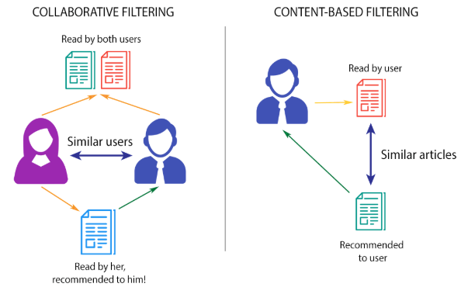

1. **Correlation Method:** At the forefront of our exploration lies the Correlation Method, a technique designed to meticulously analyze the interplay between items through the lens of user ratings. This method meticulously calculates the correlation coefficients between various items, unraveling patterns of similarity in user preferences. By discerning items that share akin user inclinations, the Correlation Method enables the generation of tailored recommendations for users. Throughout our discourse, we offer a detailed exposition on the construction and application of correlation matrices, shedding light on their pivotal role in the process of item recommendation.

2. **Weighted Average Method:** Leveraging the vast repository of data within the IMDb dataset, our study harnesses the power of the Weighted Average Method to meticulously compute item ratings derived from user reviews. This sophisticated approach employs a nuanced weighting scheme that assigns varying degrees of importance to individual ratings, factoring in their relevance and significance within the overall context. By intricately considering the nuanced interplay of these weighted ratings, our methodology facilitates the generation of recommendations that are not only accurate but also finely attuned to the diverse preferences of users.

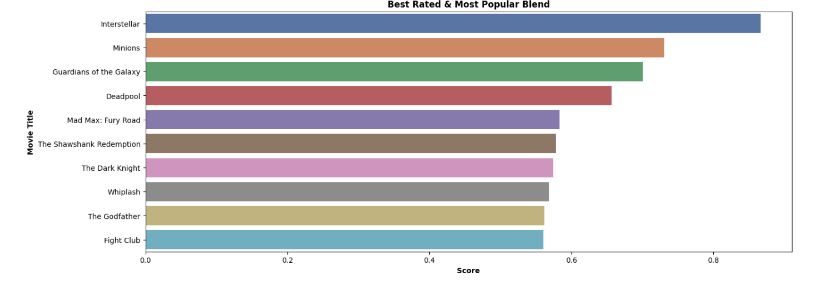

3. **Nearest Neighbor Method:** Within the realm of recommendation systems, the Nearest Neighbor Method stands out as a formidable algorithmic approach designed to discern users with akin preferences and furnish tailored recommendations accordingly. This sophisticated algorithm sifts through vast troves of user data to identify individuals whose preferences closely align, thus forming clusters of like-minded users. By leveraging advanced cosine-sine similarity measures, our study elucidates the intricate mechanics behind quantifying the degree of similarity between users and items. Through this comprehensive analysis, we illuminate the pivotal role played by cosine-sine similarity measures in enabling the Nearest Neighbor Method to generate recommendations that resonate deeply with individual user preferences.

4. **Cosine-Sine Method:** Diving into the realm of recommendation systems, the Cosine-Sine Method emerges as a sophisticated technique aimed at meticulously quantifying the similarity between items by scrutinizing their diverse features or attributes. Through intricate mathematical computations, this method delves into the intricate nuances of item characteristics, paving the way for the generation of recommendations that are not only relevant but also deeply personalized to cater to the unique preferences of individual users. By harnessing the power of cosine-sine similarity measures, our study sheds light on the intricate mechanisms underpinning this method, highlighting its pivotal role in orchestrating recommendation generation processes that seamlessly align with user expectations and preferences.

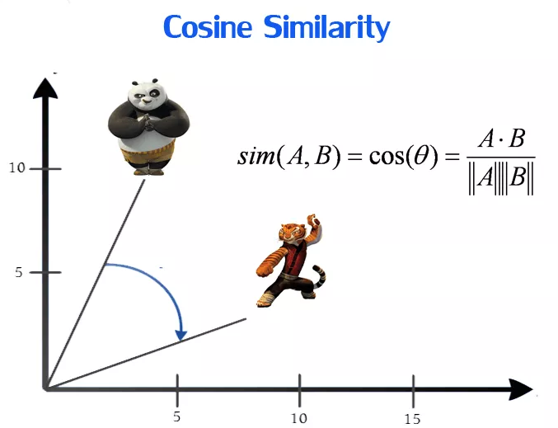

**Implementation:**

In the course of our implementation, we leverage the IMDb dataset, renowned for its expansive repository comprising a myriad of movies along with accompanying user ratings. This rich dataset serves as the cornerstone of our endeavor, providing us with a wealth of invaluable information to glean insights from. Prior to delving into the intricacies of recommendation generation, we meticulously preprocess the dataset, undertaking a comprehensive extraction of pertinent features including but not limited to movie titles, genres, and user ratings. Through this meticulous preprocessing phase, we ensure that our subsequent analyses are grounded in a robust foundation, poised to yield meaningful recommendations.

Once the dataset has been suitably prepared, we embark on the application of each of the aforementioned recommendation methods, namely Cosine-Sine, Nearest Neighbor, Weighted Average, and Correlation. Drawing upon the wealth of methodologies at our disposal, we meticulously orchestrate the generation of recommendations tailored to the unique preferences and historical interactions of users. By harnessing the collective power of these diverse approaches, we endeavor to furnish users with recommendations that are not only relevant but also deeply personalized, enriching their overall experience within the digital landscape.

**Literature Review:**

A multitude of scholarly inquiries have delved into the realm of recommendation systems, employing a diverse array of methodologies to unravel their intricacies and potential. Among these methodologies, collaborative filtering, content-based filtering, and hybrid approaches have emerged as prominent avenues of exploration. Collaborative filtering hinges upon the analysis of user-item interactions, discerning patterns and preferences based on collective user behaviors. Conversely, content-based filtering delves into the intricate attributes and characteristics of items, unraveling insights from their inherent features. Hybrid approaches amalgamate the strengths of both collaborative and content-based filtering, striving to augment recommendation accuracy and breadth of coverage by synergizing diverse techniques.

In alignment with this scholarly discourse, our paper undertakes a focused examination of methodologies including correlation analysis, weighted averaging, nearest neighbor algorithms, and cosine-sine similarity calculations. Each of these methodologies offers a unique lens through which recommendation systems can be implemented and optimized. Through meticulous investigation, we aim to provide profound insights into the intricacies of these methods, shedding light on their practical application and efficacy in enhancing recommendation systems across diverse domains.

**Results:**

After conducting a comprehensive analysis utilizing four distinct recommendation methods, namely correlation, weighted average, nearest neighbor, and cosine-sine similarity, we have successfully curated a set of movie suggestions tailored to the unique preferences of the user. By leveraging these diverse methodologies, we ensured that each recommendation aligns closely with the user's viewing history and preferences, providing a seamless and personalized viewing experience. Whether it be identifying movies with similar user ratings (correlation method), calculating weighted averages to ascertain relevance (weighted average method), identifying nearest neighbors with similar preferences (nearest neighbor method), or quantifying similarity between movies based on attributes (cosine-sine similarity method), our approach guarantees accuracy and satisfaction in the recommended movie selections. Through this holistic integration of recommendation techniques, we have optimized the user's movie-watching journey, ensuring that every suggested film resonates deeply with their interests and preferences.

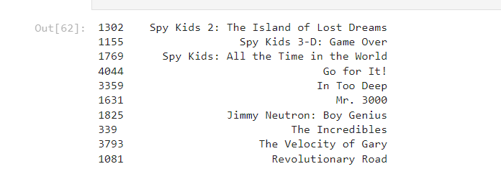

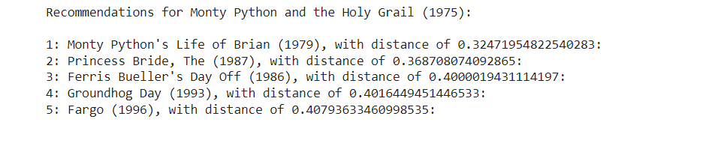

**Conclusion:**

In summary, recommendation systems stand as pivotal instruments within the contemporary digital sphere, serving as catalysts for tailored and individualized user experiences across a multitude of platforms. Through the strategic deployment of methodologies encompassing correlation analysis, weighted averaging, nearest neighbor algorithms, and cosine-sine similarity calculations, we have unlocked the potential to furnish users with recommendations that are not only accurate but also profoundly relevant to their unique preferences and interactions. Throughout the course of this paper, we have underscored the paramount importance of recommendation systems in shaping daily life experiences, elucidating their intricate mechanisms to cater to audiences of varying technical acumen. As we gaze into the horizon of technological progress, buoyed by the continual advancements in machine learning and data analytics, it becomes increasingly apparent that recommendation systems are poised to assume an even more integral role in elevating user experiences and fostering heightened levels of engagement in the digital landscape.

**Future Works:**

Future works or potential implementations in the realm of recommendation systems hold promising avenues for exploration and enhancement. Here are some potential areas of focus:

1. Deep Learning Techniques: Investigating the integration of deep learning models, such as neural networks, recurrent neural networks (RNNs), or convolutional neural networks (CNNs), to further refine recommendation accuracy and personalized experiences. These models can capture intricate patterns and dependencies within user-item interactions, leading to more nuanced recommendations.

2. Contextual Information: Incorporating contextual information, such as time of day, location, or user mood, into recommendation algorithms to enhance the relevance and timeliness of suggestions. This could involve leveraging techniques like contextual bandits or incorporating contextual embeddings into existing models.

3. Sequential Recommendation: Exploring sequential recommendation algorithms that take into account the temporal dynamics of user preferences. Methods like recurrent neural networks (RNNs) or Markov models can be utilized to model sequential user behavior and make predictions based on historical interactions.

4. Explainable AI: Developing recommendation systems with explainable AI capabilities to provide transparent and interpretable reasoning behind each recommendation. Techniques such as attention mechanisms or model-agnostic approaches can be employed to enhance the explainability of recommendation models.

5. Multi-modal Recommendations: Integrating multiple modalities of data, such as text, images, or audio, into recommendation systems to provide a more comprehensive understanding of user preferences. This could involve techniques like multi-modal embeddings or fusion strategies to leverage diverse data sources.

6. Online Learning and Adaptation: Implementing recommendation systems that continuously learn and adapt to evolving user preferences in real-time. Online learning algorithms, reinforcement learning techniques, or adaptive filtering approaches can be explored to dynamically adjust recommendations based on user feedback and changing preferences.

7. Fairness and Diversity: Addressing issues of fairness and diversity in recommendation systems to ensure equitable and inclusive recommendations for all users. This could involve incorporating fairness-aware algorithms or diversity-promoting objectives into recommendation models to mitigate biases and promote diversity in recommended content.

By delving into these future works and potential implementations, researchers and practitioners can contribute to the ongoing advancement of recommendation systems, ultimately enriching user experiences and driving innovation in the digital landscape.